Project Documentation
Introduction
This project is a CPU Scheduling Simulator that compares two preemptive scheduling algorithms: Priority Scheduling and SRTF (Shortest Remaining Time First). The user enters a set of processes, runs the simulation, and the system generates two Gantt charts, two results tables, a comparison summary, answers to the required analysis questions, and a four-point conclusion. Everything is implemented in a single HTML file, so the simulator runs directly in the browser without a server, database, or installation requirements.
Project Structure
The project is organized as a single-file web application. The HTML builds the interface, the CSS controls the design and layout, and the JavaScript performs the logic such as reading inputs, validating data, running both scheduling algorithms, calculating metrics, building results tables, and drawing the Gantt charts.
Input Panel
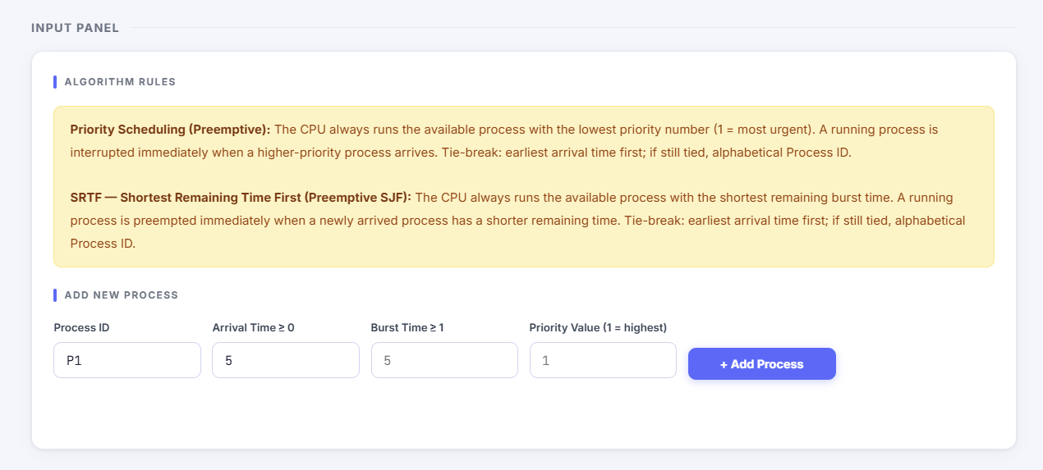
The simulator accepts four required inputs for each process:
- Process ID
- Arrival Time
- Burst Time
- Priority Value
Each input field has a matching error-message area below it. The input element is used to receive user data, while the paired error area is used by JavaScript to display validation messages if the value is invalid. This design keeps validation feedback clear and directly connected to the field that caused the error.
Important note: this project does not use Time Quantum, because Time Quantum is only required in Round Robin scheduling. In this project, the compared algorithms are Priority Scheduling and SRTF, and both run according to their own selection rules without a quantum value.

Validation
Before a process is added, JavaScript validates all four fields. If a field is invalid, the simulator highlights the input with a red border and shows an error message below it. If all values are valid, the process is stored in the process list and displayed in the process table.
Validation rules used in the simulator:
Invalid input | Error message
Empty Process ID | Required
Negative arrival time, such as -3 | Must be ≥ 0
Zero or negative burst time | Must be ≥ 1
Negative priority value | Must be ≥ 1
Duplicate Process ID | Duplicate ID
Non-numeric value in numeric field | Must be a number
Missing field | Required

The validation logic is split into two levels. A helper function checks a single field and returns true or false, while the add-process function reads all four inputs, validates them, checks for duplicate IDs, stores the process if valid, and then refreshes the visible process table.
Process Table
The process table shows the current set of processes that will be used by both algorithms. JavaScript generates this table dynamically as HTML text and inserts it into the page. Each row displays the process ID, arrival time, burst time, priority value, and a delete option.
This section is important because the same workload must be used for both Priority Scheduling and SRTF. That is necessary for a fair comparison between the two algorithms.
Test Scenarios
The simulator includes four preset scenarios stored as JavaScript objects. Each scenario loads a prepared dataset into the process list so the user can test the algorithms quickly and consistently.

Scenario A: Basic Mixed Workload
Scenario A represents a normal workload with multiple processes, different arrival times, and different burst times. It is used to demonstrate the general behavior of both Priority Scheduling and SRTF under mixed conditions.
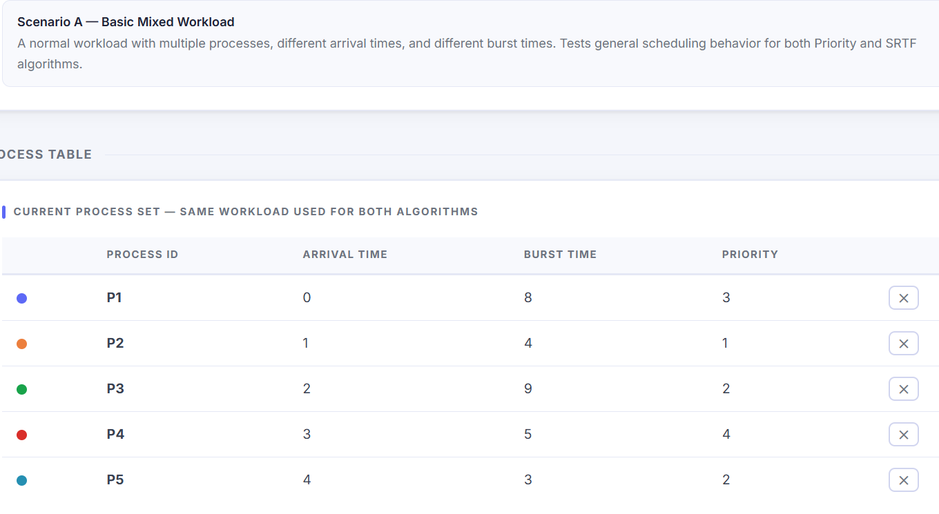
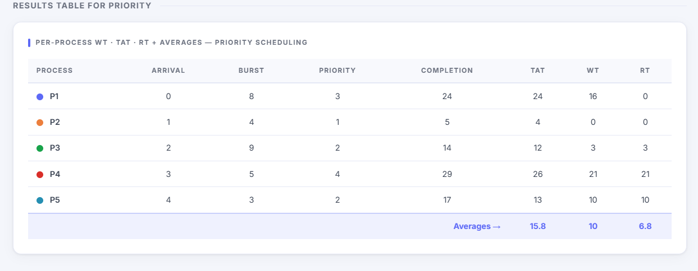
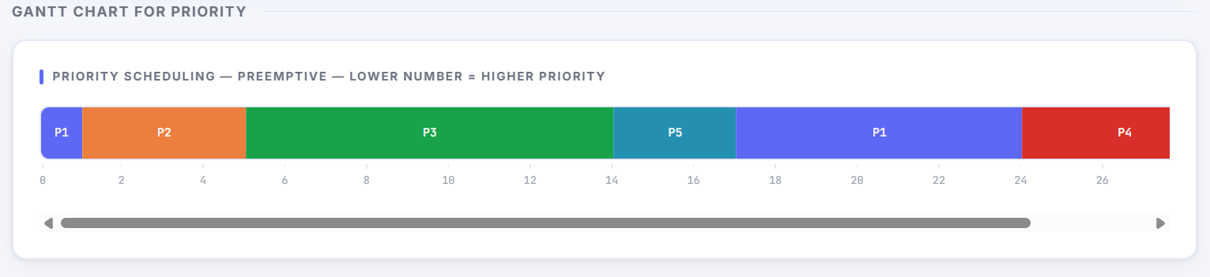
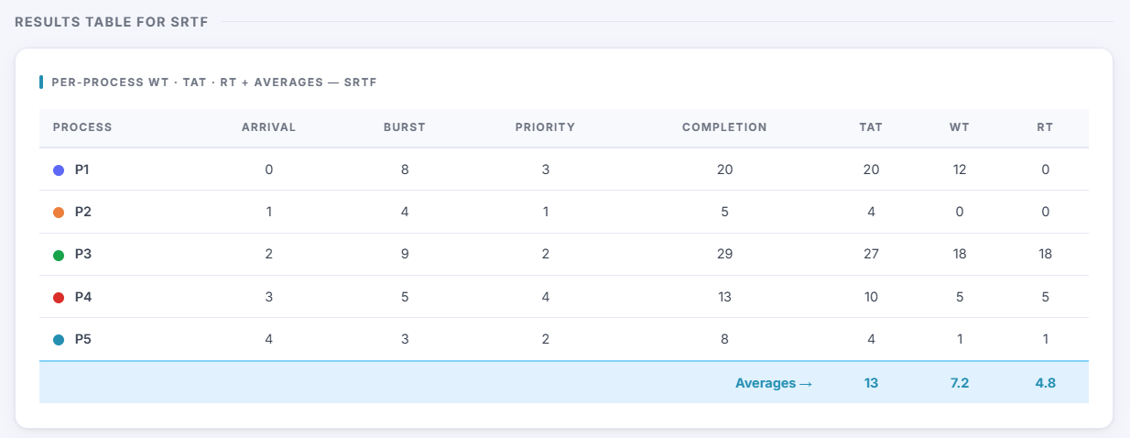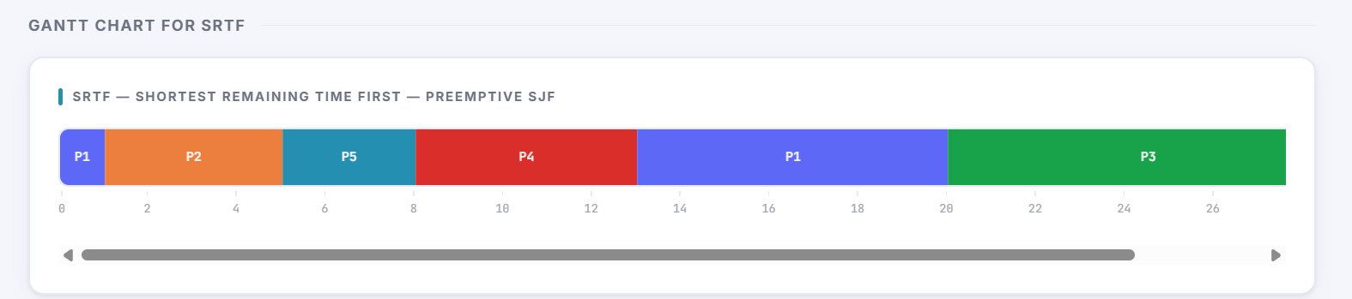
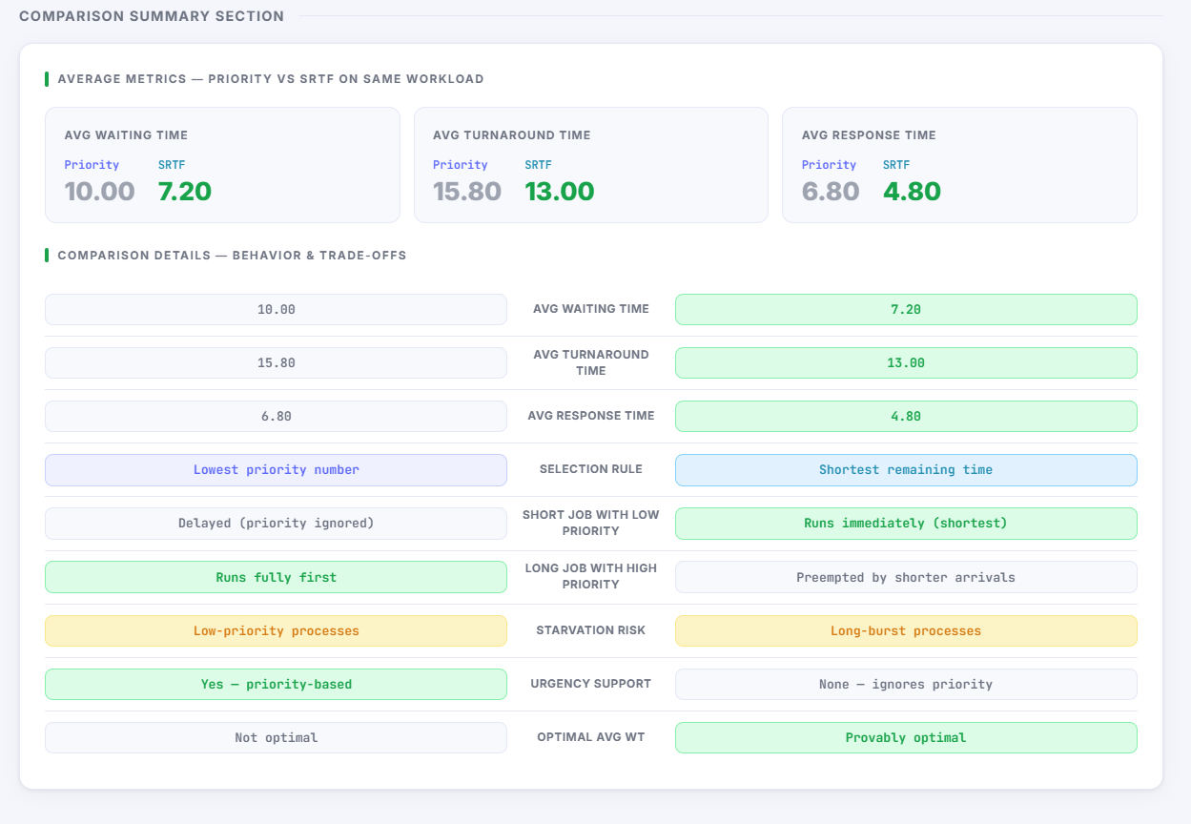
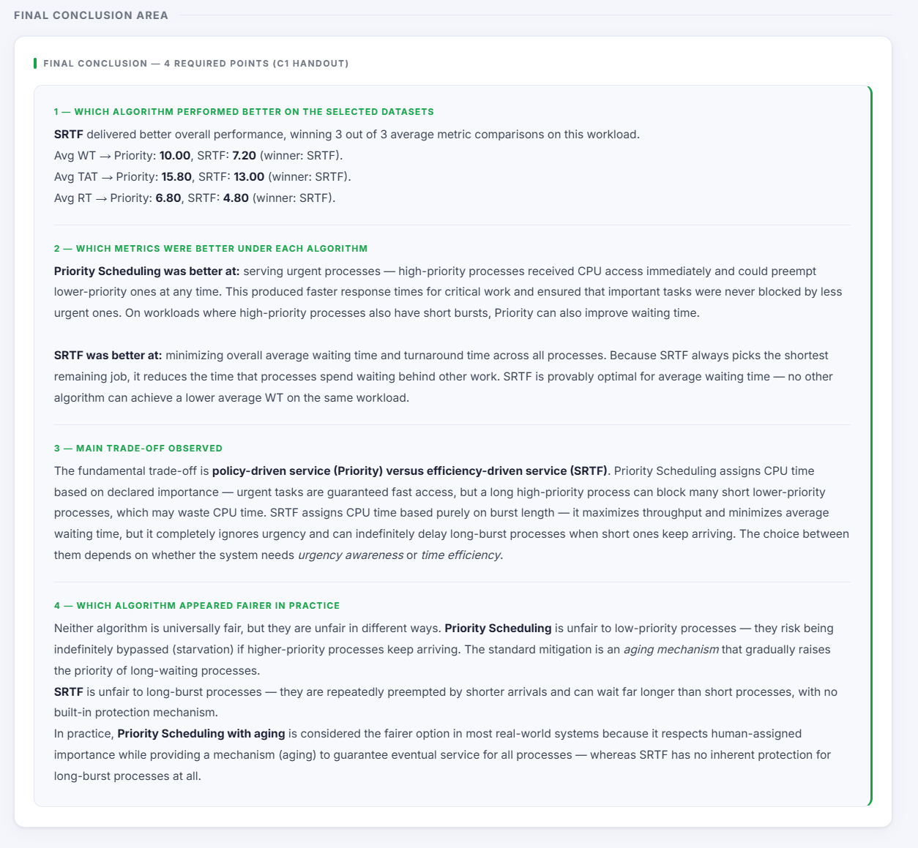

Scenario B: Priority vs Burst Conflict
Scenario B is designed so that one process has high priority but a long burst time, while another process has lower priority but a short burst time. This scenario helps show the key difference between the two algorithms: Priority Scheduling follows urgency based on priority value, while SRTF prefers the shortest remaining burst. 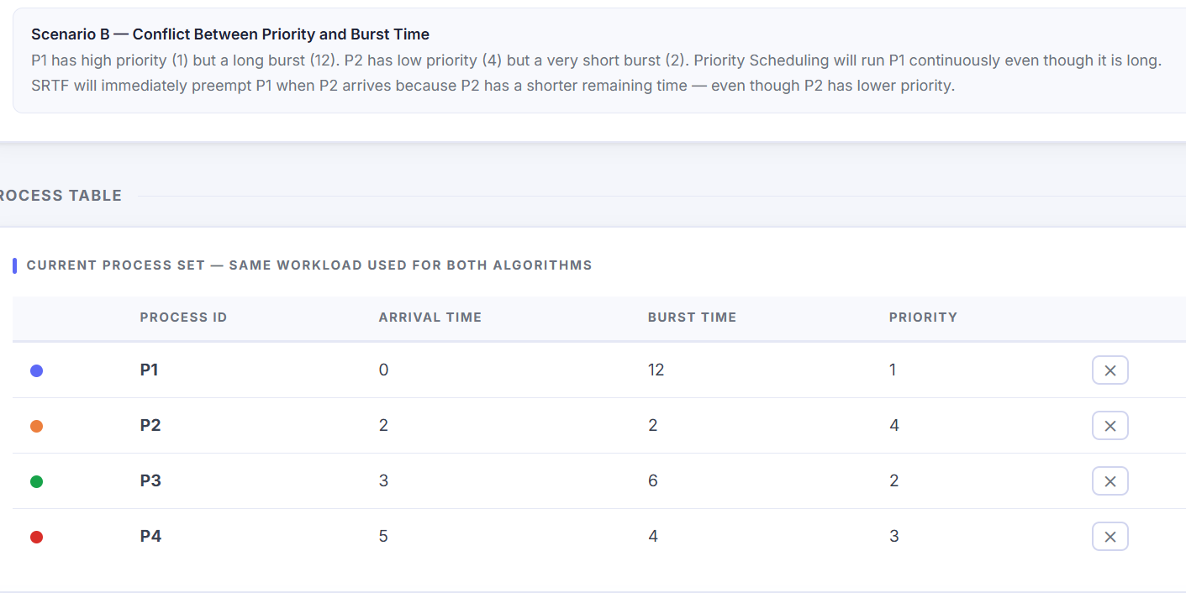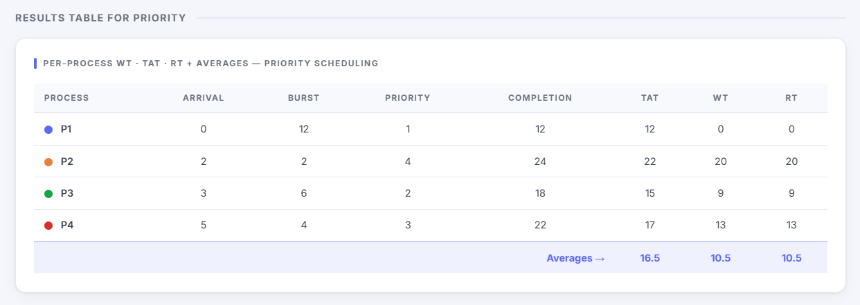
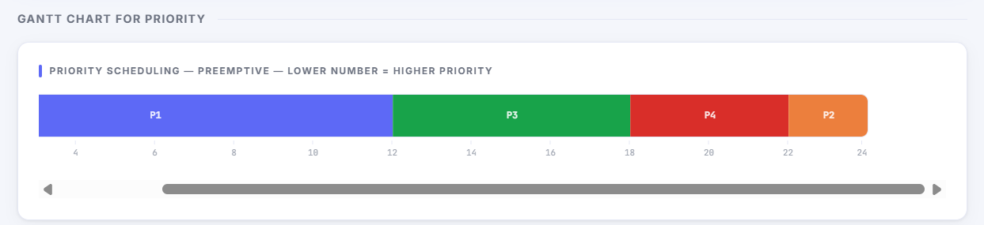
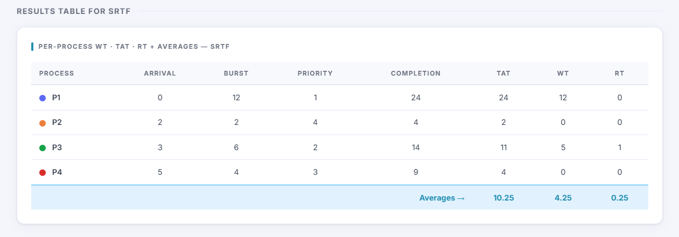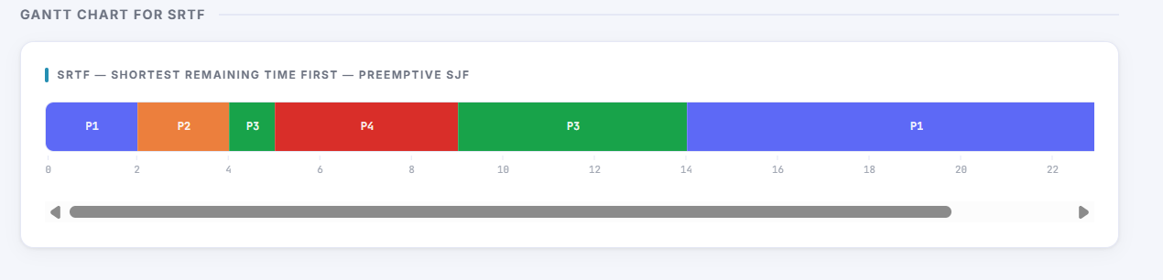
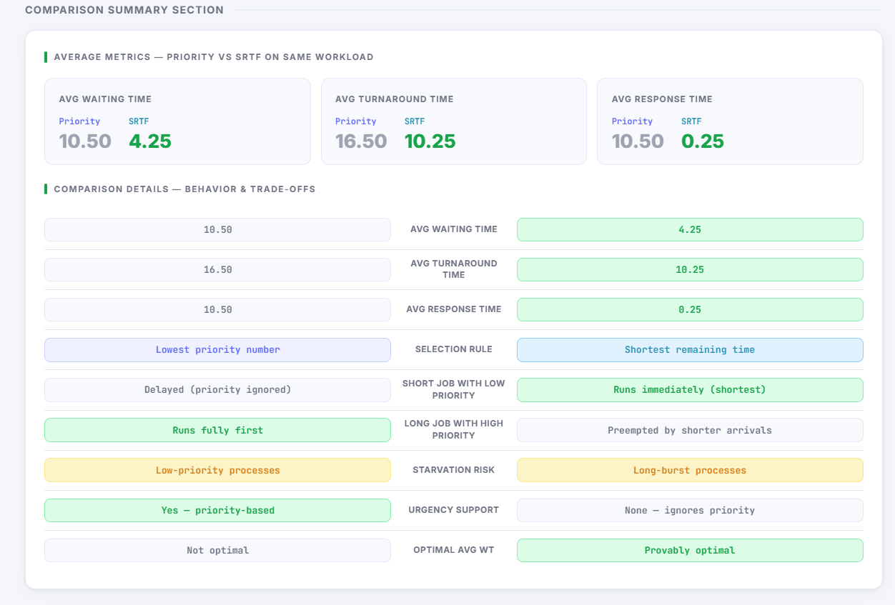
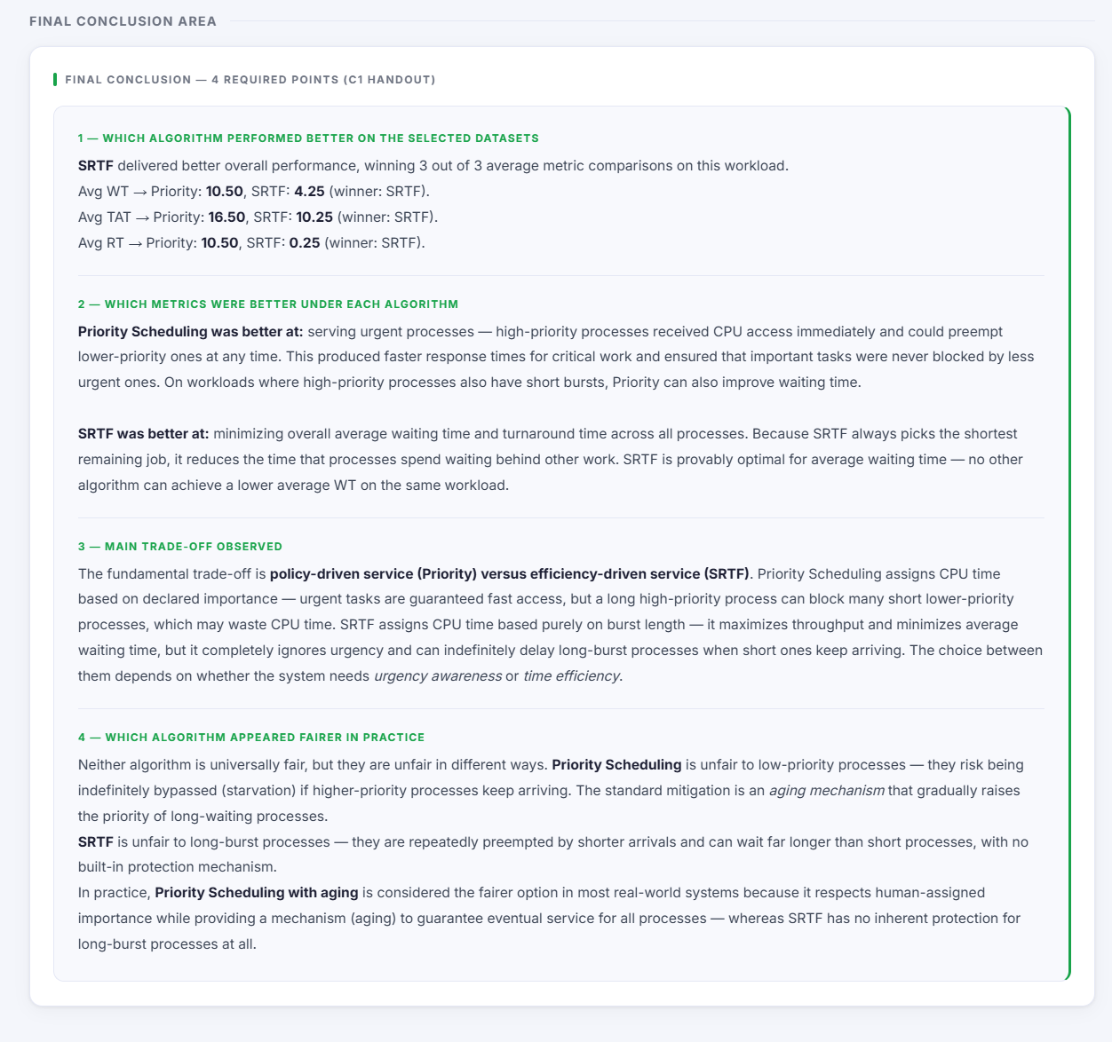
Scenario C: Starvation-Sensitive Case
Scenario C is used to show starvation risk. A low-priority process may wait too long under Priority Scheduling because more urgent processes keep arriving, while under SRTF a long-burst process may also wait because shorter jobs keep preempting it.
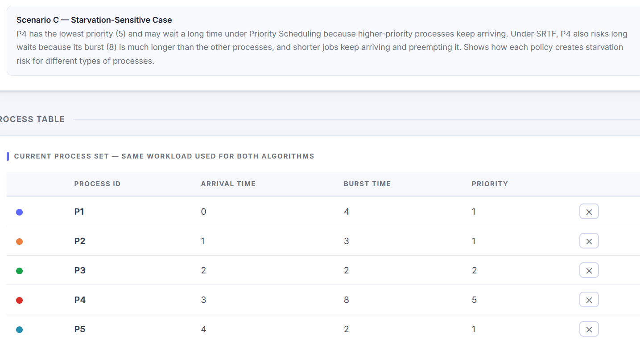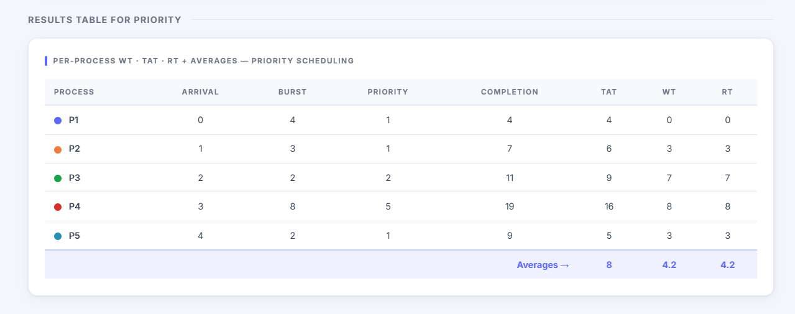
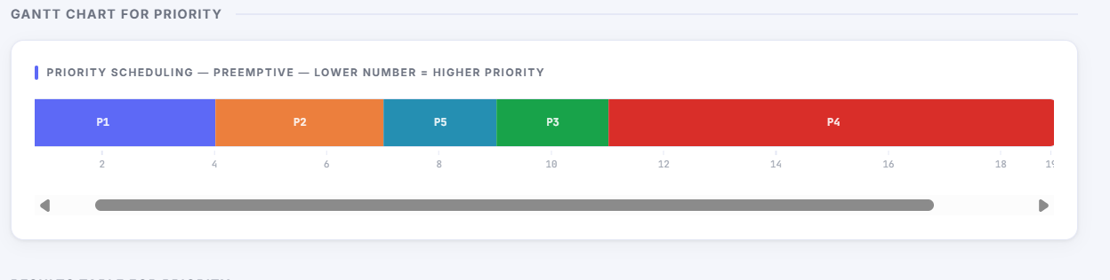

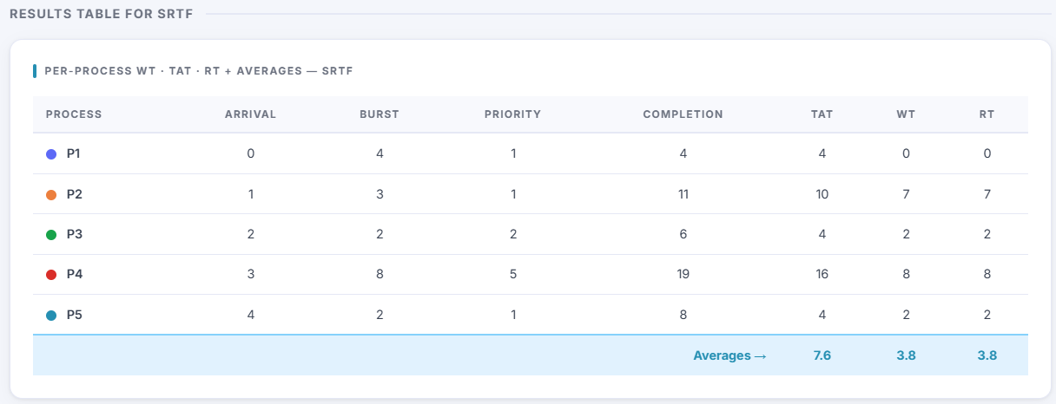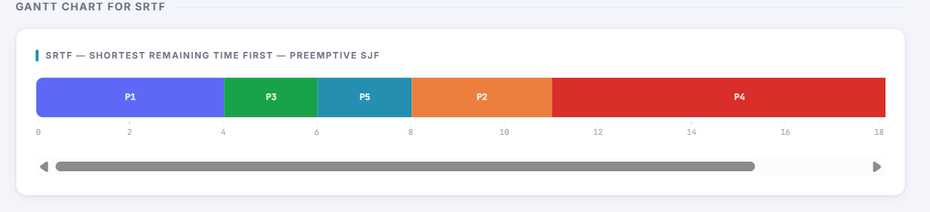
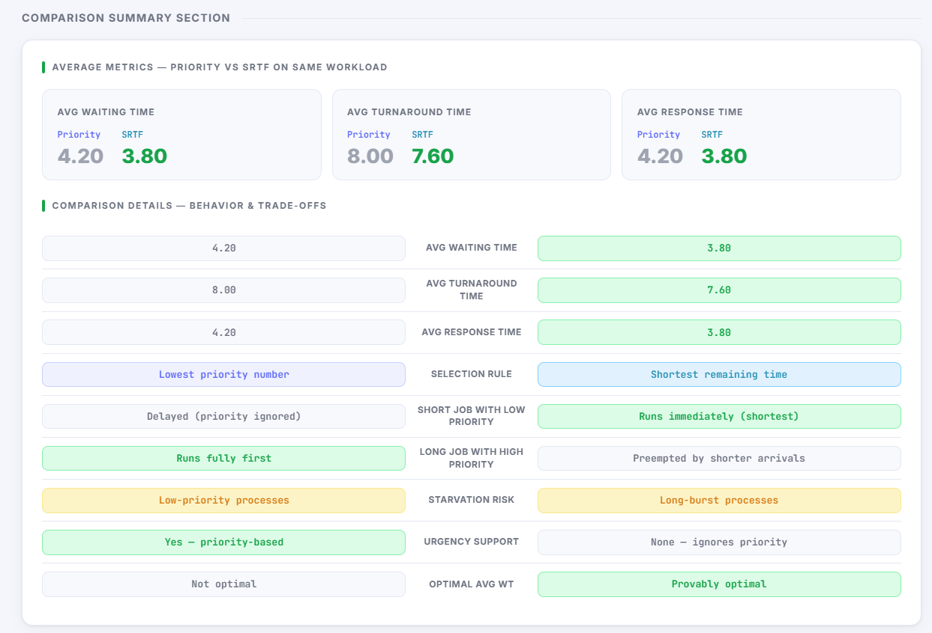
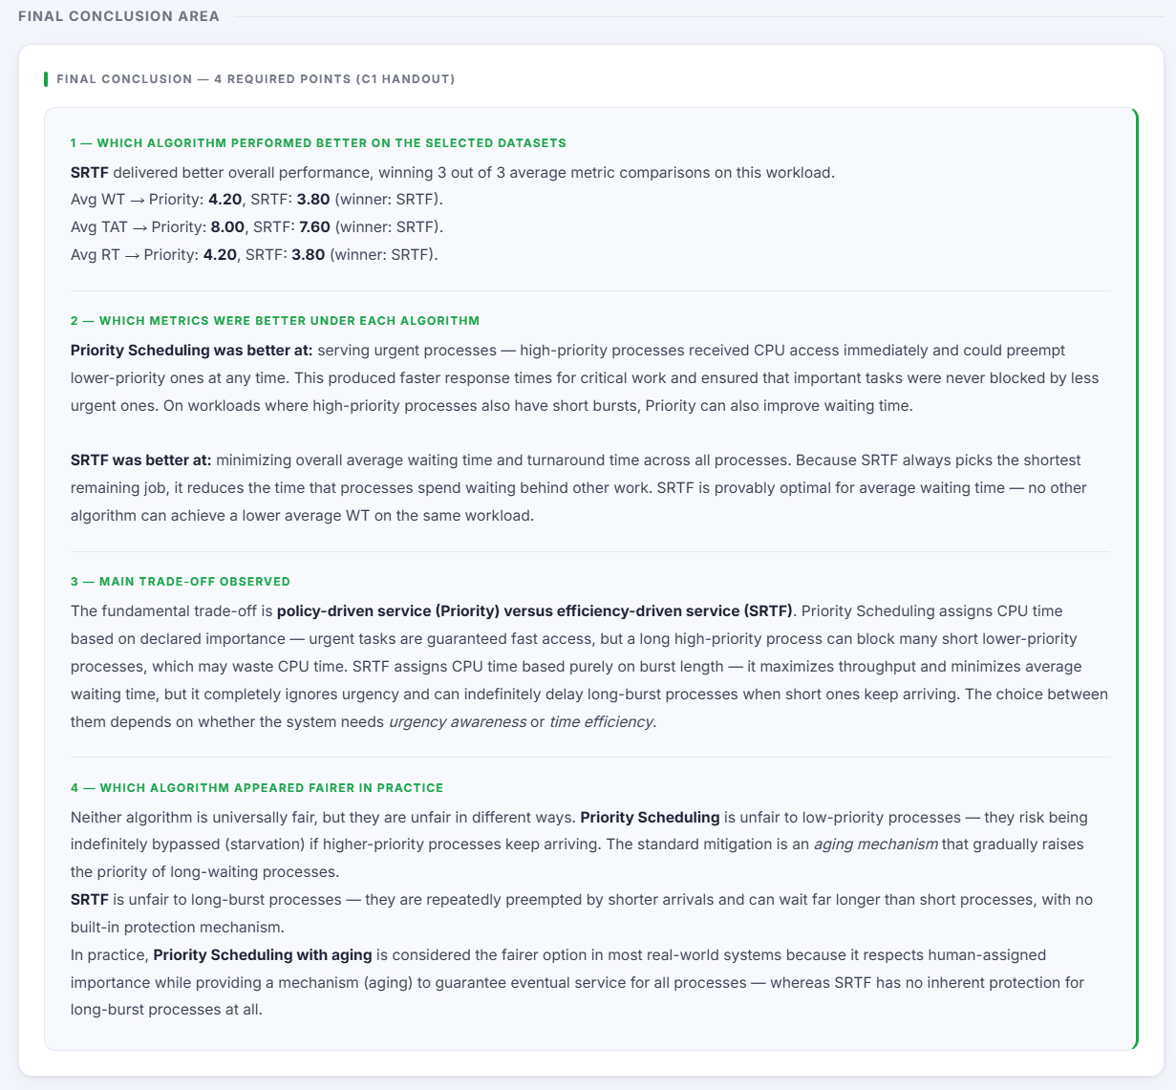Scenario D: Validation Case
Scenario D demonstrates that invalid inputs are safely rejected. It is used to prove that the simulator handles validation errors correctly while still allowing a valid dataset to be loaded so the simulation can continue.
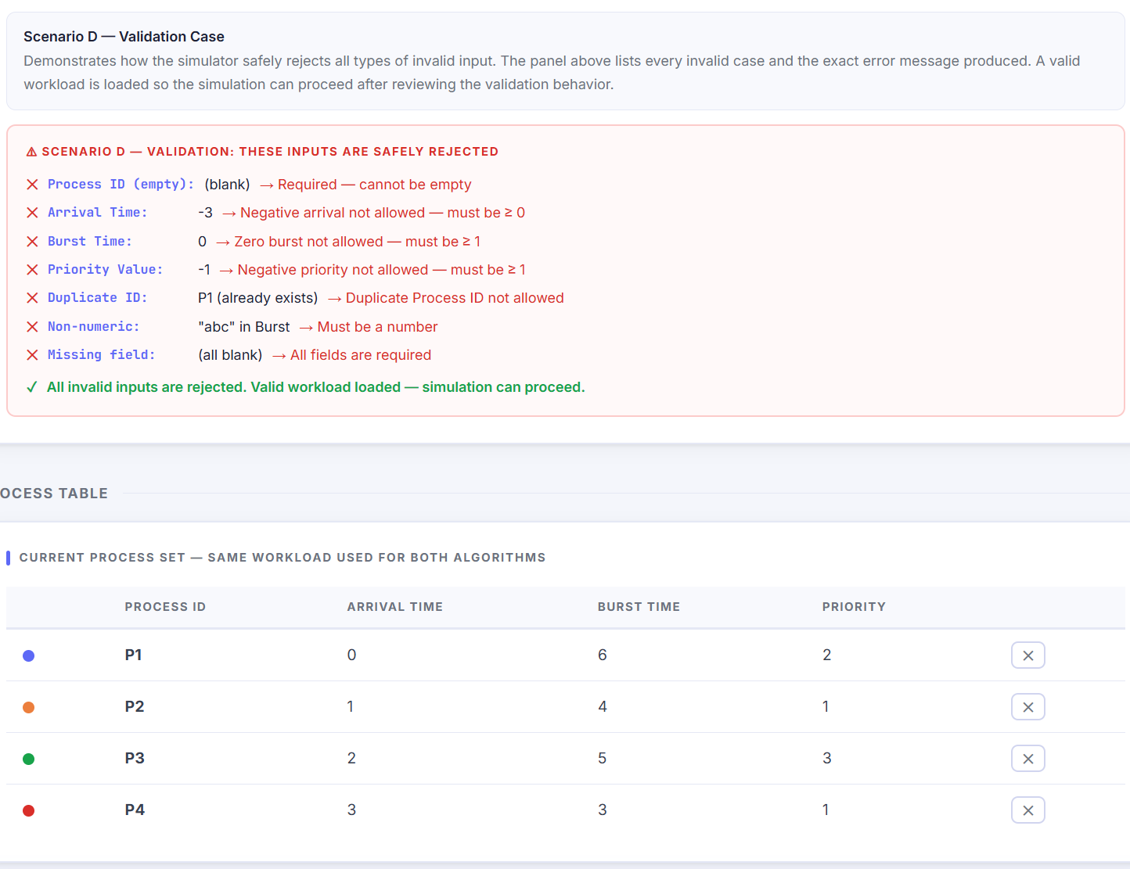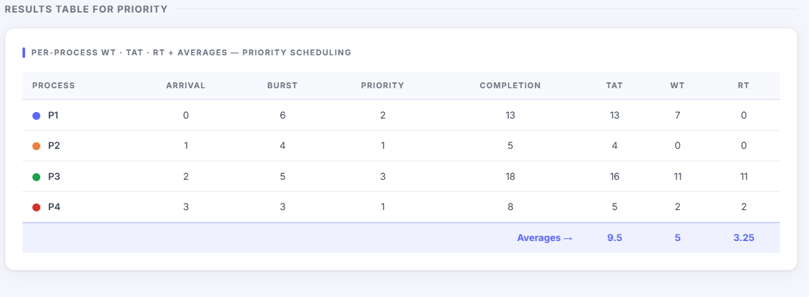
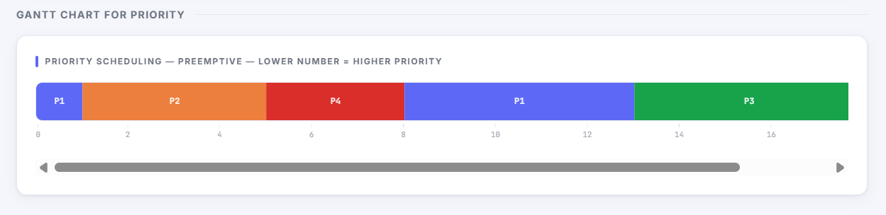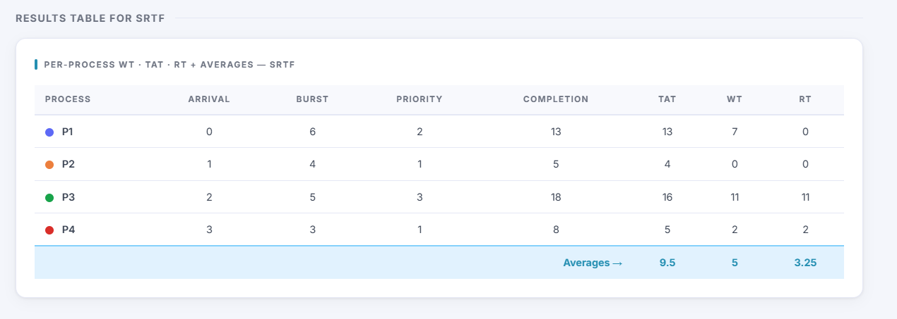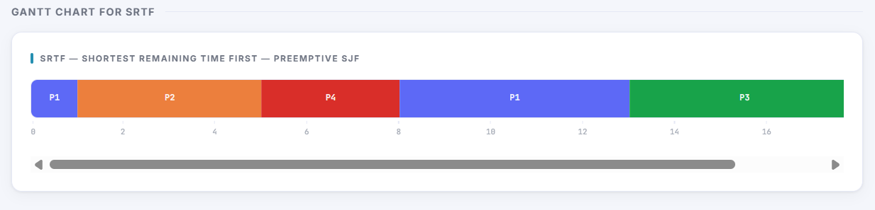
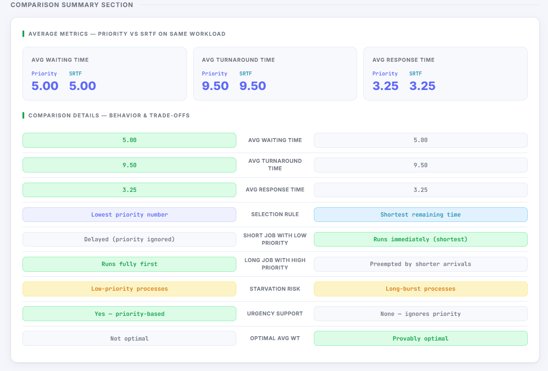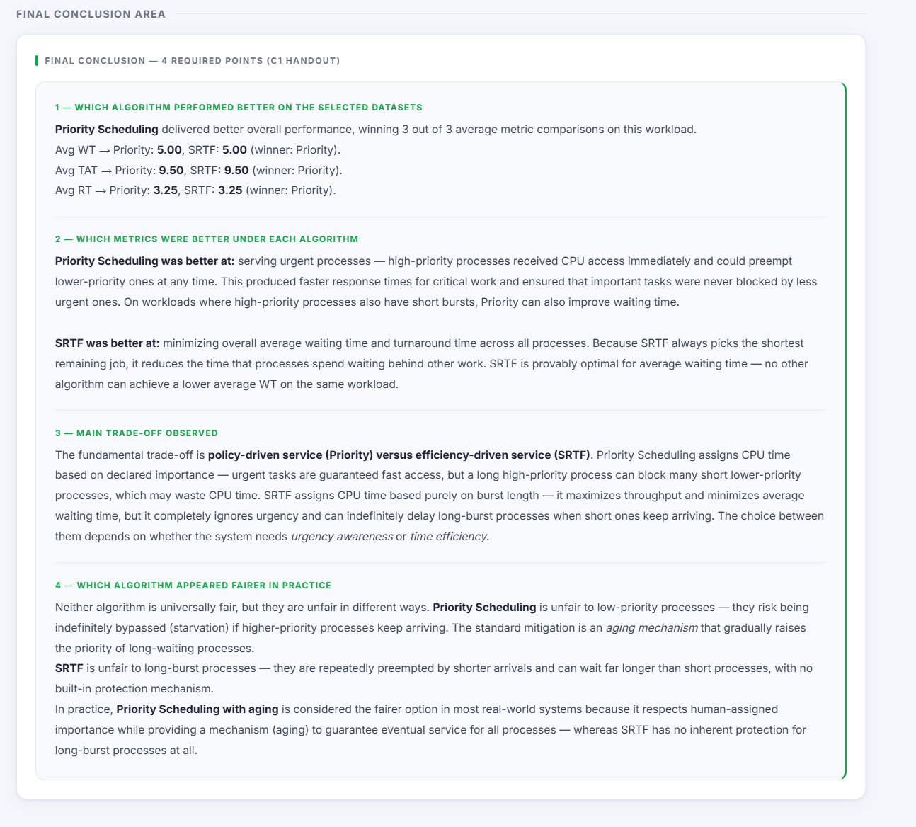
Priority Scheduling Algorithm
Priority Scheduling in this project is preemptive. The CPU always selects the available process with the lowest priority number, because a lower number means higher urgency. If a new process arrives with a higher priority than the currently running process, the current process is interrupted immediately.
The algorithm follows these steps:
- Find all processes that have arrived and still have remaining burst time.
- Select the process with the lowest priority number.
- If there is a tie, choose the earliest arrival time; if still tied, choose the alphabetical process ID.
- Check whether a future process with higher priority will arrive before the current one finishes.
- Run until completion or until preemption is required, then record the segment in the Gantt chart.
SRTF Algorithm
SRTF stands for Shortest Remaining Time First, which is the preemptive form of Shortest Job First. The CPU always chooses the available process with the smallest remaining burst time. If a newly arrived process has a shorter remaining time than the currently running one, the running process is preempted immediately.
The purpose of this algorithm in the project is to compare its scheduling behavior and performance with Priority Scheduling on the exact same workload.
Performance Metrics
The simulator calculates three metrics for each process:
- Waiting Time (WT)
- Turnaround Time (TAT)
- Response Time (RT)
These metrics are used to measure and compare algorithm performance.
Definitions:
- Waiting Time is the total time a process spends waiting in the ready queue before execution.
- Turnaround Time is the total time from process arrival until completion.
- Response Time is the time from process arrival until the process gets CPU time for the first time.
Gantt Charts
After simulation, the system generates one Gantt chart for Priority Scheduling and one Gantt chart for SRTF. Each Gantt chart shows the execution order of processes over time and helps visualize when preemption occurs.
These charts are useful because they make the behavioral difference between the two algorithms easy to observe, especially in scenarios where priorities and burst times conflict.
Results Tables
The simulator creates one results table for each algorithm. Each table lists the process-level values for WT, TAT, and RT, and also includes an averages row. The averages are later used in the comparison summary.
This design supports both detailed analysis at the process level and summary comparison at the algorithm level.
runSimulation Workflow
The runSimulation function acts as the controller of the whole simulator. When the user clicks Run, it performs the main steps in the correct order.
Main sequence:
- Validate that at least two processes exist.
- Build the process color map.
- Run Priority Scheduling on the process list.
- Run SRTF on the same process list.
- Calculate metrics for both results.
- Render both Gantt charts.
- Render both results tables.
- Render the comparison summary.
- Render the analysis answers.
- Render the final conclusion.
- Reveal the hidden results section.
Using the same process list for both runs is required to ensure that the comparison is valid.
Comparison Summary
The comparison summary presents the average values of WT, TAT, and RT side by side, then adds short behavior-based comparisons. The guide states that a comparison is only valid when both algorithms run on the same dataset, and the simulator follows that rule by passing the same process list to both scheduling functions.
The comparison section discusses:
- Which algorithm had the lower average WT
- Which algorithm had the lower average TAT
- Which algorithm had the lower average RT
- The selection rule used by each algorithm
- What happens to short jobs with low priority
- What happens to long jobs with high priority
- Starvation risk in each algorithm
- The theoretical advantage of SRTF in minimizing average waiting time
Analysis Questions
The project includes five required analysis questions. The guide explains that the answers are based on actual simulation results rather than personal opinion, and the explanations are written to connect the measured results to scheduling theory.
The analysis should answer questions such as:
- Which algorithm produced the lower average waiting time?
- Which algorithm produced the lower average response time?
- How did each algorithm behave with short jobs and long jobs?
- Which algorithm showed starvation risk, and why?
- What general conclusion can be drawn from the experiment?
When writing these answers in the final document, the explanation should mention both the actual measured result and the theoretical reason behind it.
Final Conclusion
The final conclusion should be written as four clear points based on the simulator output and the theory of the algorithms. The guide positions this as a required part of the handout, and it should summarize the most important findings from the comparison.
A strong conclusion can state the following ideas:
- Priority Scheduling and SRTF make decisions using different criteria: priority value versus shortest remaining burst time.
- SRTF is generally better at reducing average waiting time because it favors short remaining jobs.
- Priority Scheduling is useful when urgency is more important than fairness or overall average waiting time.
- Both algorithms can suffer from starvation, but the reason is different in each case: low-priority jobs in Priority Scheduling and long jobs in SRTF.

